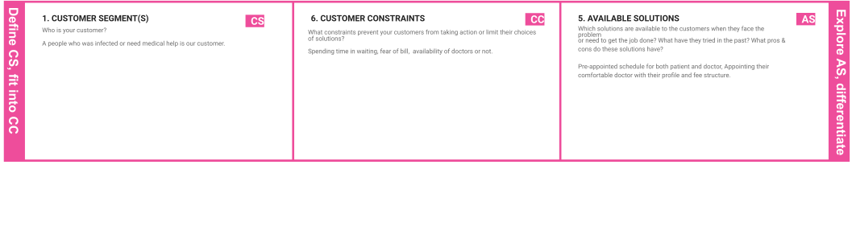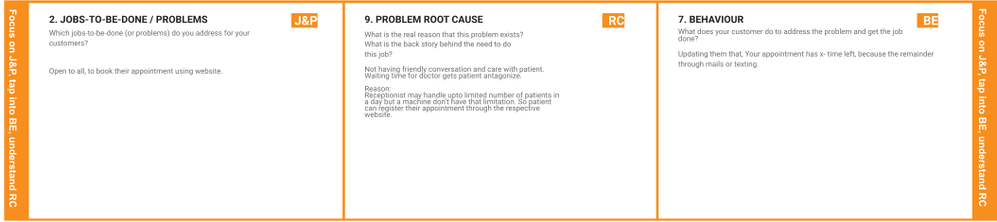

**Project Title:** Analytics For Hospitals' Health-Care Data **Project Design Phase-I** - **Solution Fit Team ID:** PNT2022TMID38936

**I 3. TRIGGERS**

# D TR

What triggers customers to act?

# E

Fear of fitness.

**N**

# T

**I 4. EMOTIONS: BEFORE / AFTER**

# F EM

How do customers feel when they face a problem or a job and afterwards?

# Y

Before:

Patients feel hereafter they don’t need to continue, lose faith, Feel insecure. After:

**S** Patients were satisfied by selecting their desired doctor and got well by quality treatment.

**T**

**R O N G**

**T R**

**& E M**

**10. YOUR SOLUTION**

# SL

A Patient needs a way to analyze and choose a Doctor by their profile because of their experience and comfort.

1. **CHANNELS of BEHAVIOUR CH**

## ONLINE

What kind of actions do customers take online? Extract online channels from #7

Instead of interacting with a doctor in physical mode, Patient can consult the doctor in online mode in an emergency situation.

## OFFLINE

What kind of actions do customers take offline? Extract offline channels from #7 and use them for customer development.

In Spite of consulting the doctor in online mode, a patient can interact with the doctor would be more adequate.